This program will allow the user to select 3 categories of food，drink, anddesert. The food price, drink price they need store inarray. And if they need desert ,they need store in array. If they don’t need another order, it will compute and display the order and total.

Set prices as doubles, selection, anotherorder as Char.

Piza=20.00

Chicken=15.00

Spaghetti=25.00

Sprite=5.00

Coke=4.00

Mountain Dew=3.00

Ice cream=10.00

Pie=12.00

Cinnamon Roll=8.00

selection

anotherselecton

Console write lines

“ Welcome to Rigby Restaurant

------------Food-------------------

Pizza Chicken Spaghetti

$20 $15 $25

-------------------Drink------------------------

Sprite Coke MountainDew

$5 $4 $3

---------------------Deserts------------

Ice Cream Pie Cinnamon Roll

$10 $4 $3

Do you wantDesert?(Y/N)

Retrieve char food type from user.

Char foodTye =user response

Store foodType in array

Retrieve char drink type from user.

Char drinkTye =user response

Store drinkType in array

Ask and retrieve char desert type from user to determine if they want a desert, yes or no.

Char desert= user response

Store desertType in array

Ask another order from user start the sequence over if yes ,

If no, calculate the price and then display the total.

//compute total price

If (Y)

{totalPrice=foodPrice+DrinkPrice+desertPrice

}

If (N)

{totalPrice=foodPrice+DrinkPrice}

//Ask another order?(Y/N)

If(Y)

{ start the sequence over}

If（N）

{

Calculate the total price and display the total

}

//Print out:

1. Your order was:
2. Your total was:

//End of Program

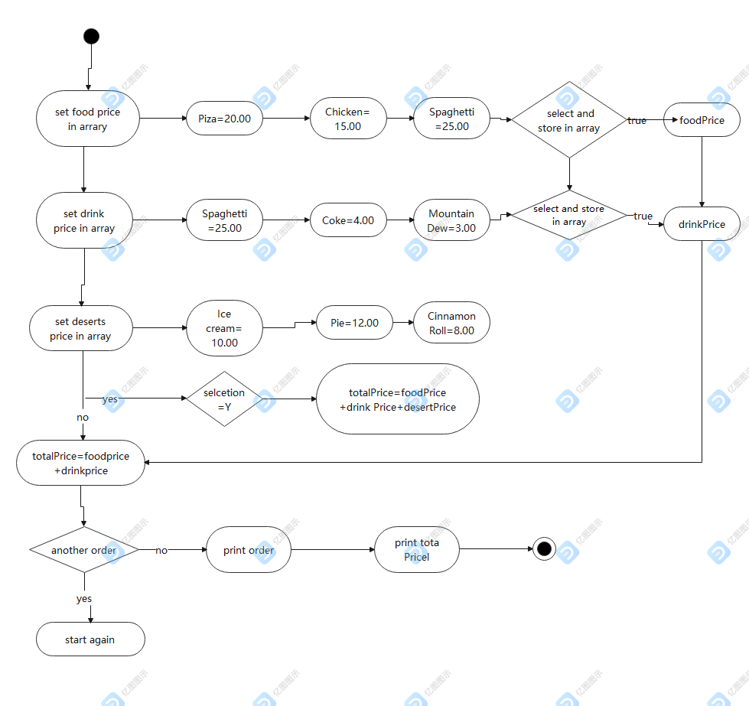

2.This program will allow the user to use random object to generate random from1-10 ,and then evaluate the random number for it .

Set the meaning of number from 1-10 as string.

Set number as int.

Console write lines

“ Welcome to evaluate the number meaning”

Generate a random number.

// print the meaning of the number

Switch

{ Case 1:

// print the meaning of 1

break;

Case 2:

// print the meaning of 2

break;

Case 3:

// print the meaning of 3

break;

Case 4:

// print the meaning of 4

break;

Case 5:

// print the meaning of 5

break;

Case 6:

// print the meaning of 6

break;

Case 7:

// print the meaning of 7

break;

Case 8:

// print the meaning of 8

break;

Case 9:

// print the meaning of 9

break;

default:

// print the meaning of 10

break;

}

//Print out:

The meaning of number

//End of program

